Coast Guard Care Anywhere
How to Transfer a Member
February 1, 2021

This training document will explain the options for transferring members between districts.
- Option 1 - Manual Transfer*
  - At Check-Out
  - At Check-In
- Option 2 - Bulk Transfer
  - Spreadsheet Format
*If manually transferring members becomes burdensome (couple dozen+), you have the option to send us a spreadsheet and we’ll automate the transfer.

Manual Transfer

- At Check-Out – Right before the patient is transferred, while you still have access to the patient in the Patient Care List, follow the steps in the screenshot below to change/assign the patient to their new resource group.
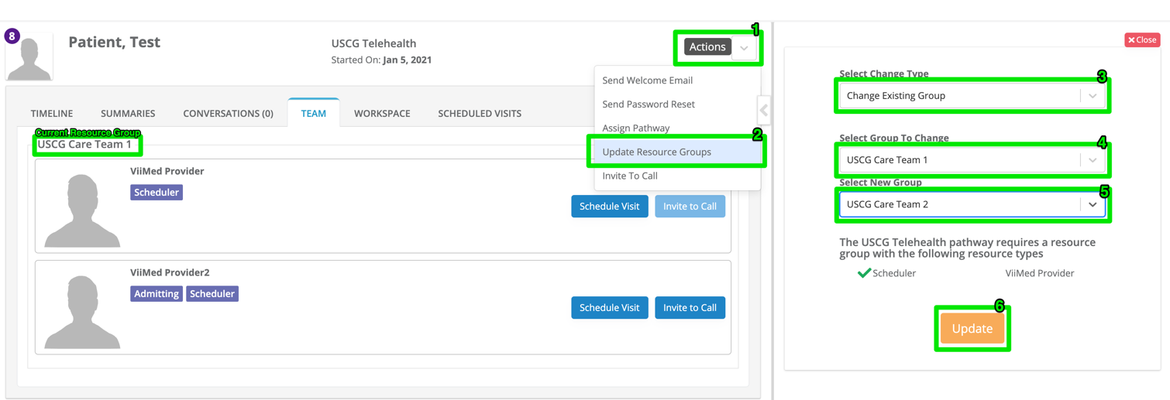

Remember - The Patient Care List is populated with patients who have been assigned to your Resource Group. Once you change the resource group, you may no longer find the patient in your Patient Care List.

- At Check-In – When the new patient arrives at your clinic, you will not be able to find the patient in your Patient Care List as they’ll still be assigned to their original Resource Group. In order to gain access to this patient and change the Resource Group to your clinic, you’ll need to temporarily add yourself to their original Resource Group.
For Example: User “Test Patient” arrives at your clinic to check-in. After you search for the last name of “Patient” on your Patient Care List, it returns zero results.
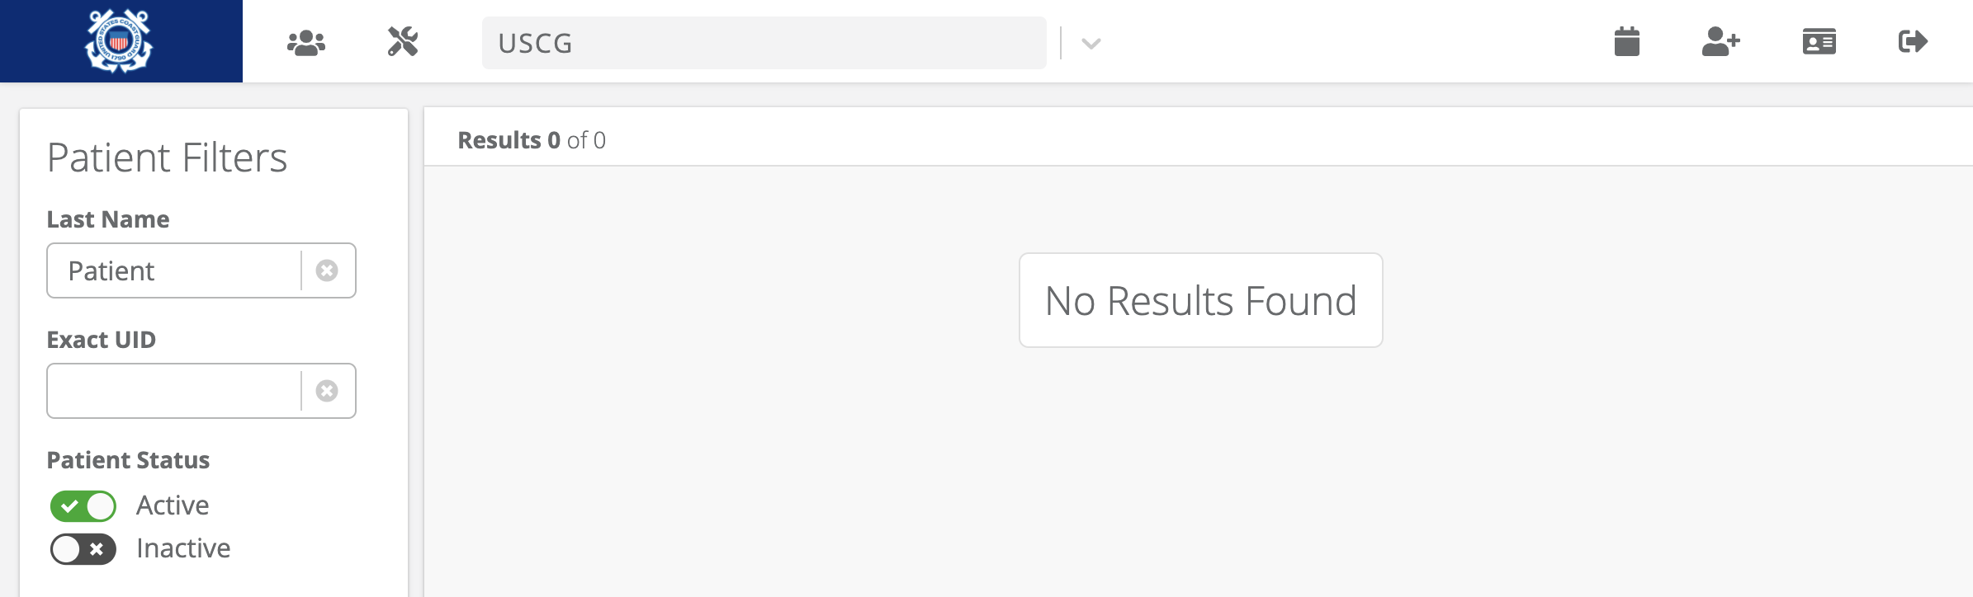

Then, “Test Patient” lets you know that they were transferred from Resource Group “USCG Care Team 1.” To gain access, you have to temporarily add yourself to the “USCG Care Team 1” Resource Group following the steps below:
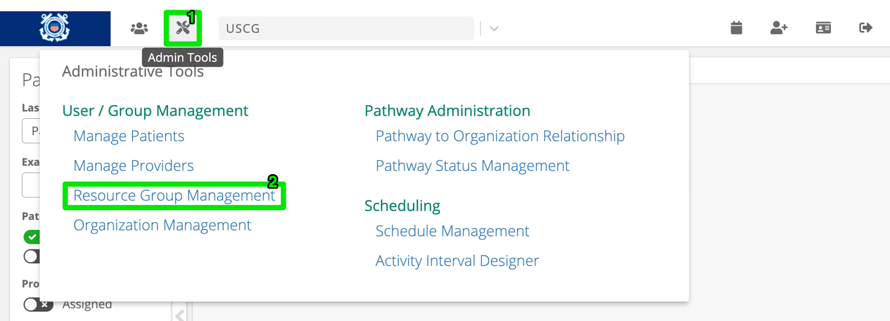

Search for “USCG Care Team 1” and add temporarily add yourself as a member.
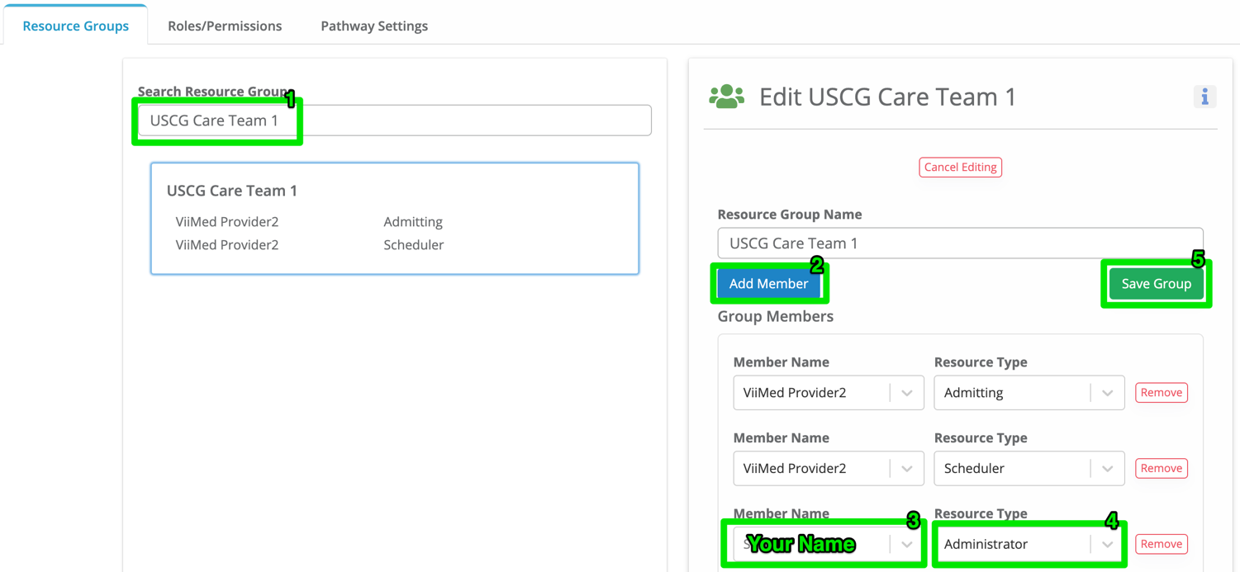
Now, if you search for “Test Patient,” they’ll appear on your Patient Care List
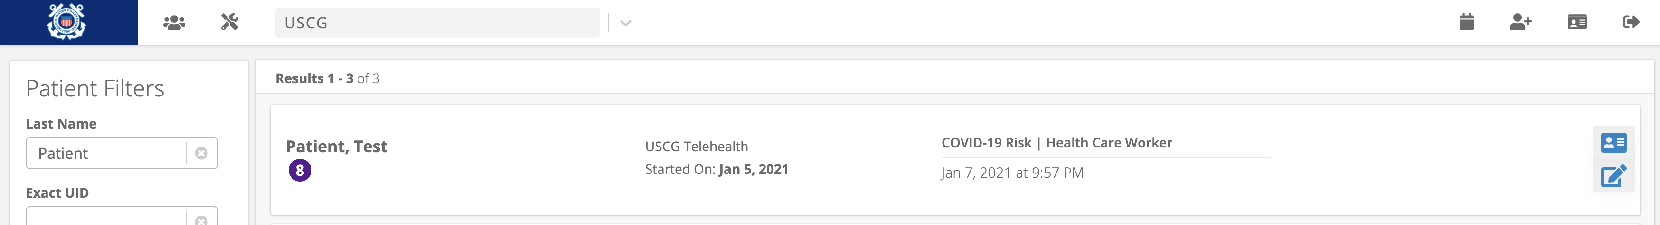

Now that you have temporary access, change the existing Resource Group to your Resource Group so that you and everyone in your Resource Group can access the patient.
Lastly, don’t forget to remove yourself from the Resource Group that you are normally not a member.

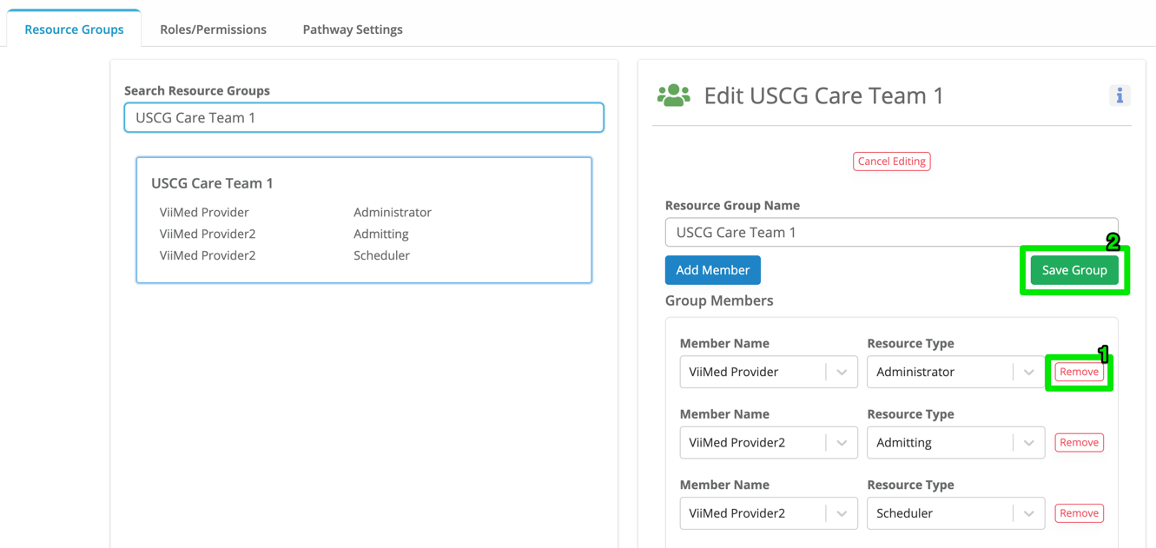

Bulk Transfer
- Spreadsheet Format

Member Email | Transfer Destination (Resource Group)
Leslie.R.Clark@uscg.mil | D1 CG Base Boston

